**Ejemplo Ítem 1**





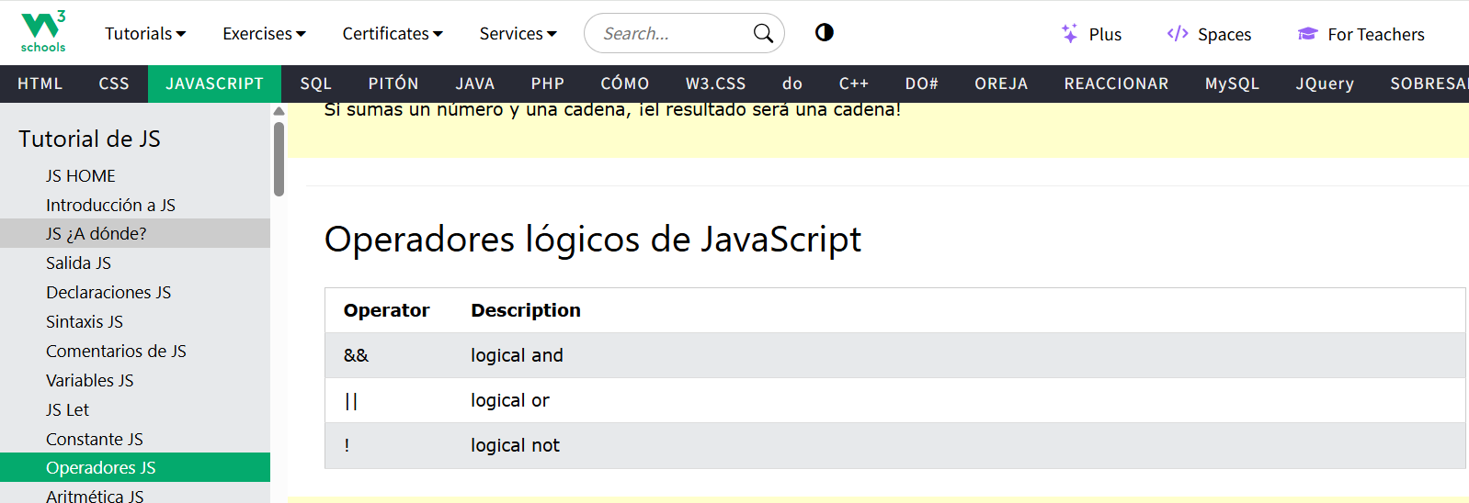

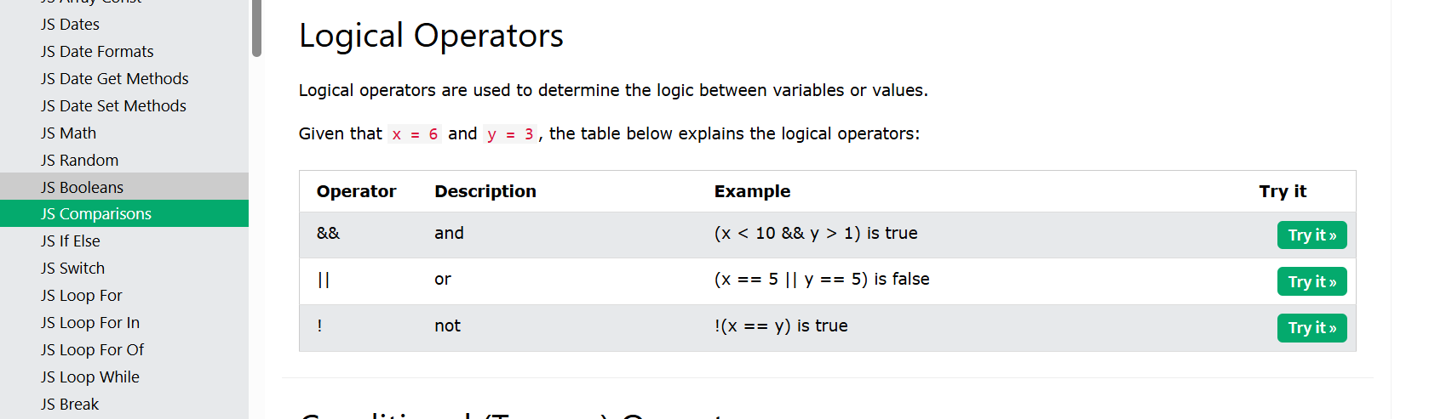

<https://www.w3schools.com/js/js_operators.asp>

**Ejemplo Ítem 2**

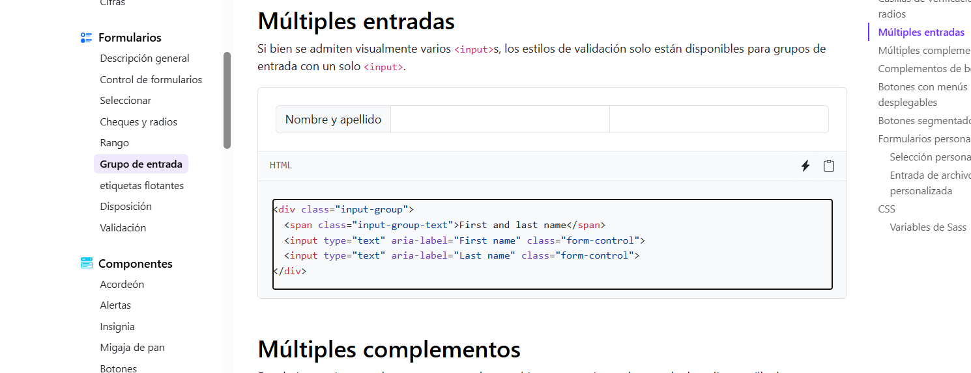

<https://getbootstrap.com/docs/5.3/forms/input-group/>

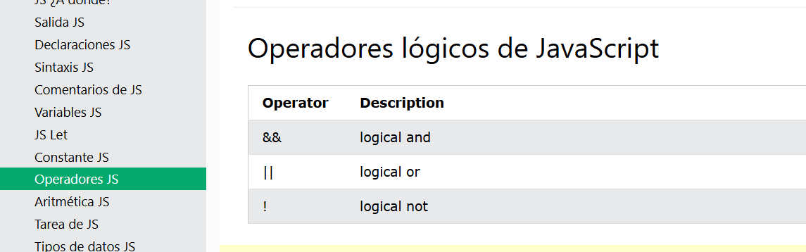

<https://www.w3schools.com/js/js_operators.asp>

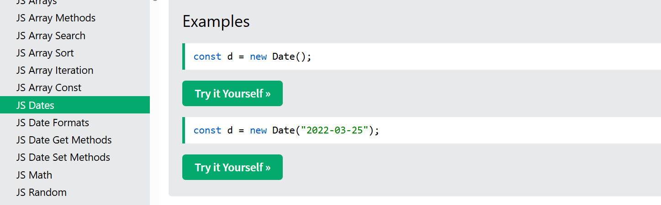

<https://www.w3schools.com/js/js_dates.asp>

**Ejemplo Ítem 3**

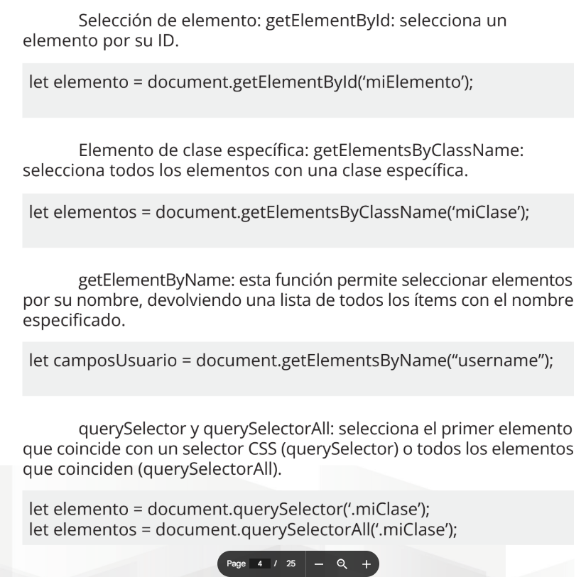

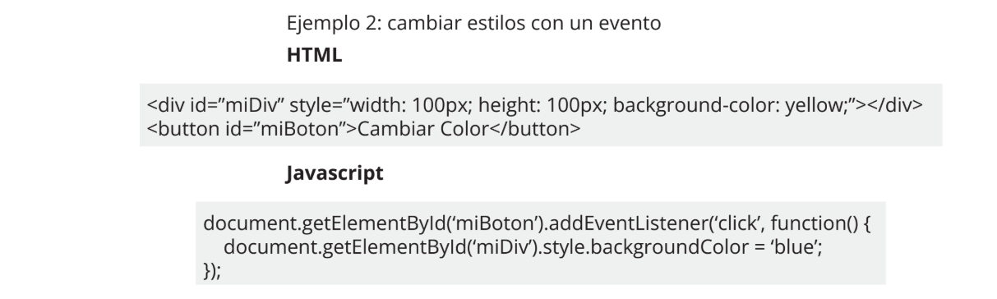

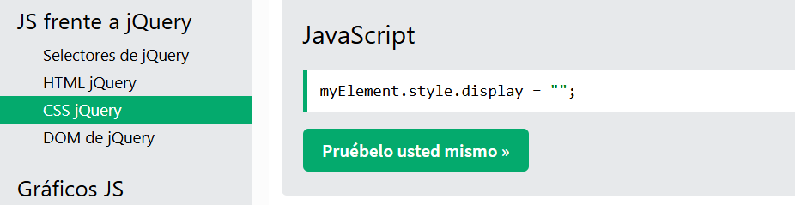

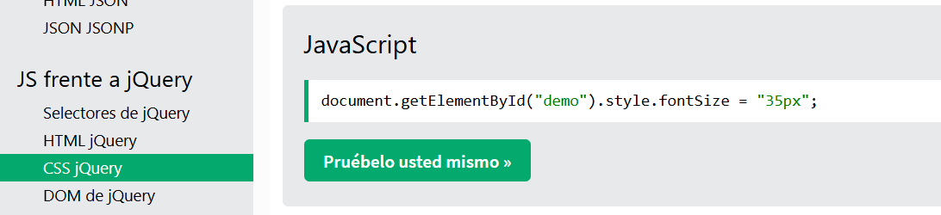

<https://www.w3schools.com/js/js_objects.asp>



<https://coolors.co/9cc578-e9ce2c-f9dc5c-e5f993-0d79ed>